

*submitted by*

**PRANAV PRAKASAN**

**19BCI0007**

*Course code*

**CSE4019**

*Course Name*

**IMAGE PROCESSING**

*Faculty*

**Akila Victor**

*Slot*

**G1**

**SCHOOL OF COMPUTER SCIENCE AND ENGINEERING**

**Table of Contents**

|  |  |  |
| --- | --- | --- |
| Index | Title | Page Number |
| 1 |  |  |
| 2 |  |  |
| 3 |  |  |
| 4 |  |  |
| 5 |  |  |
| 6 |  |  |
|  |  |  |

**List of Figures**

|  |  |  |
| --- | --- | --- |
| Index | Title | Page Number |
| 1 |  |  |
| 2 |  |  |
| 3 |  |  |
| 4 |  |  |
| 5 |  |  |
| 6 |  |  |
| 7 |  |  |
|  |  |  |

1. **Abstract**

The project focusses on building 3D models from buildings’ segmentation from satellite images. The software built for the project takes an image as input, predicts the segmentation using a machine learning model, followed by a series of image processing techniques to identify the contours and areas of the identified building segments. This information is carried on to create the 3D models.

1. **Aim**

The aim is to create a project that allows to build 3D models from buildings’ segmentation from satellite images.

1. **Objective**

The objective of the project is to create a software that would identify and build 3D models of buildings from an input image. The objectives include the following:

1. Creating a CNN based machine learning model to predict the segmentation of buildings in the image
2. Create a flow of image processing steps on the intermediate results to prepare the contour information for the Unity module
3. Create the Unity module which uses this information to create 3D models
4. **Literature survey**
5. **Proposed Methodology**
   1. **High Level Overview**

Modules Involved:

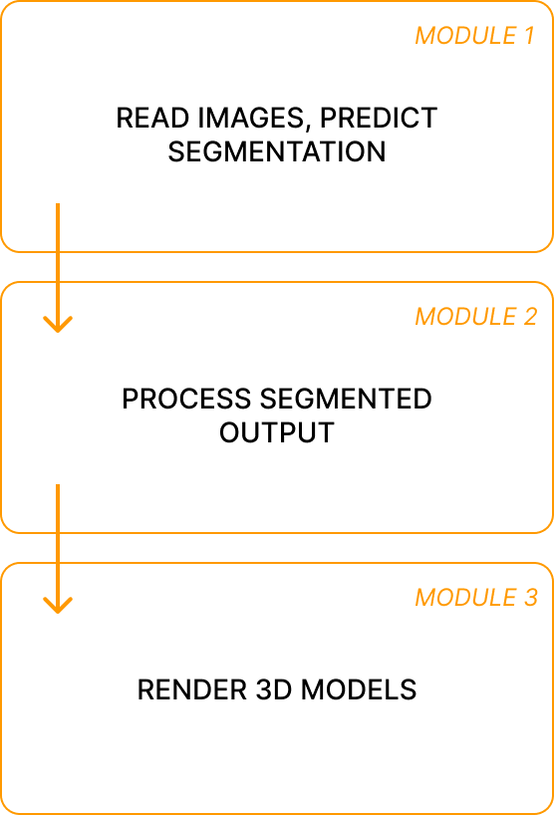

*Fig - Modules involved: High Level*

* 1. **Module Description:**

**5.2.1 Segmentation Prediction using machine learning model**

This module uses a machine learning model to predict the segmentation of buildings in the input image.

The machine learning model is trained using a dataset obtained from Kaggle.

**5.2.1.1 Dataset**

Link: <https://www.kaggle.com/code/kmader/segmenting-buildings-in-satellite-images/data>

Total number of images: 281,000

1. Image processing on Segmentation
2. Render 3D models

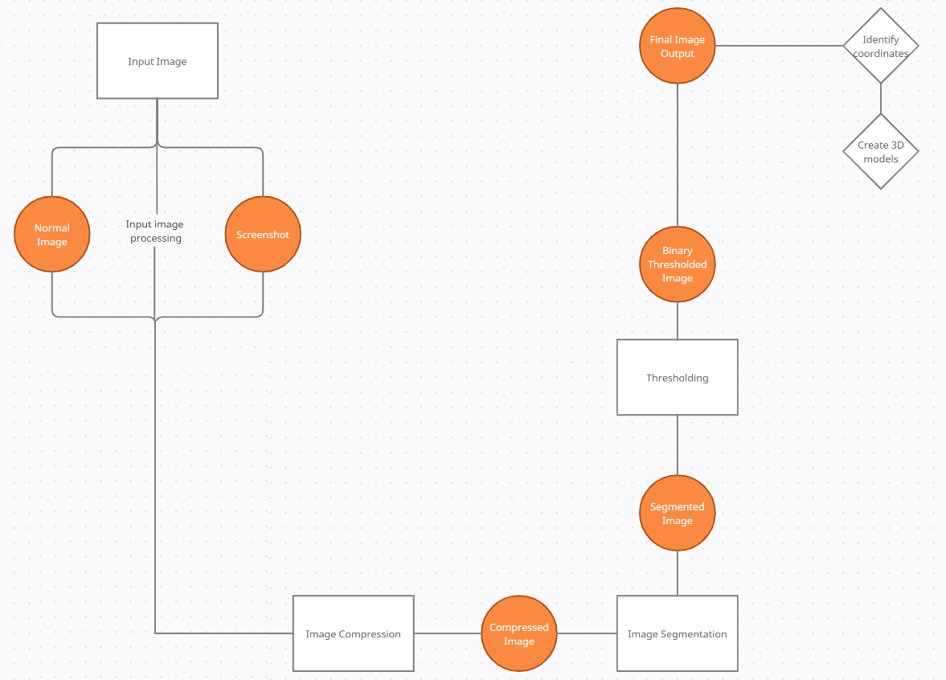

*Fig - Module 2: Process segmented output*

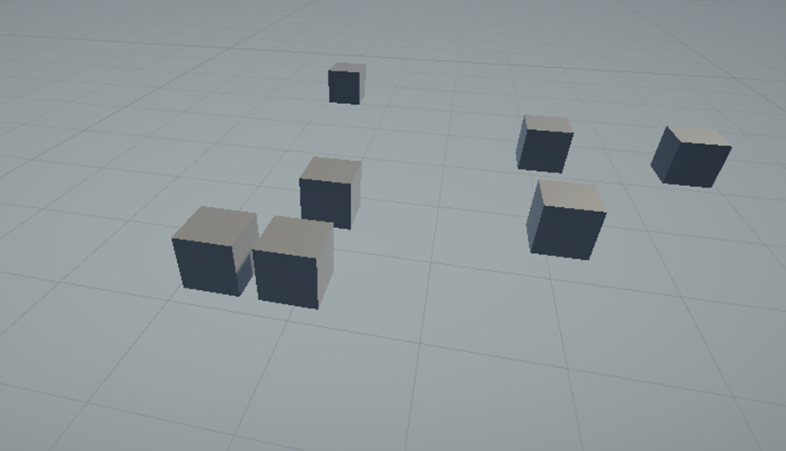

*Fig - Module 3: Rendered 3D models of the identified segmented buildings*

The image input is taken, followed by compression. The compressed image is fed into a trained machine learning model. The machine learning model predicts the accurate segmentation for the buildings in the image. The segmentation is preformed followed by a thresholding operation. The threshold output is further processed in the following order.

1. Bilateral Filter
2. Color space transformation from BGR to GRAY
3. Dilation
4. Erosion
5. Canny Edge Detection
6. Contour Detection

The output yields the image with contours marked as well as the areas of each identified contour. This information is now passed to the Unity module. The Unity module creates 3D blocks of the respective areas as returned by the previous module.

**Results**

The web application renders a 3D model of the segmented buildings in the input image